LAB 7
Animation
ANIMATION:
Slide Transition + Fade Transition -> Entrance Animation
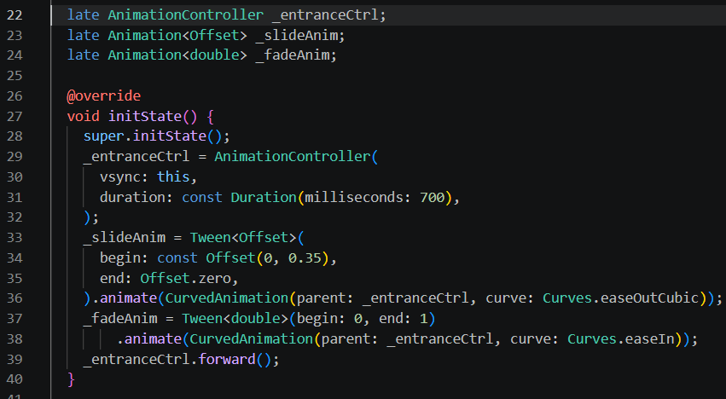
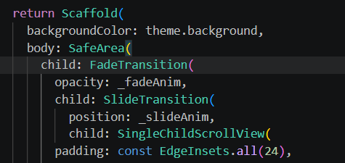

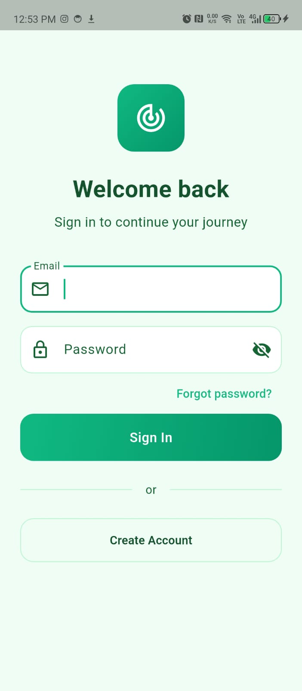
Login Screen Animation:
- Animation can’t be properly seen within screenshots
- Every time the Login screen opens
- the logo, title, input fields and buttons all slide up smoothly
- from 35% below while fading from invisible to fully visible
- takes 700ms with easeOutCubic curve for a natural feel.
Goal Screen :
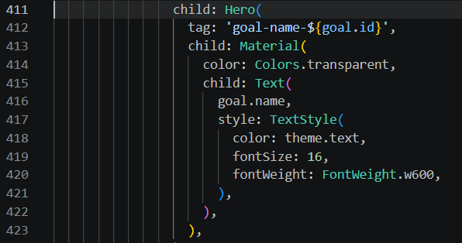
Goal details screen:
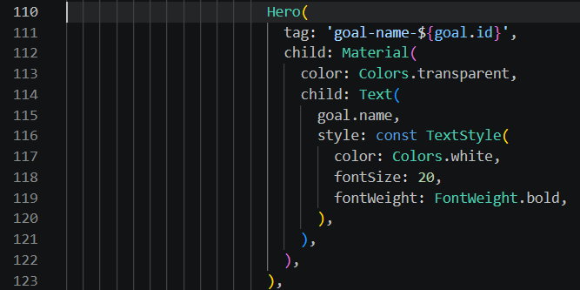

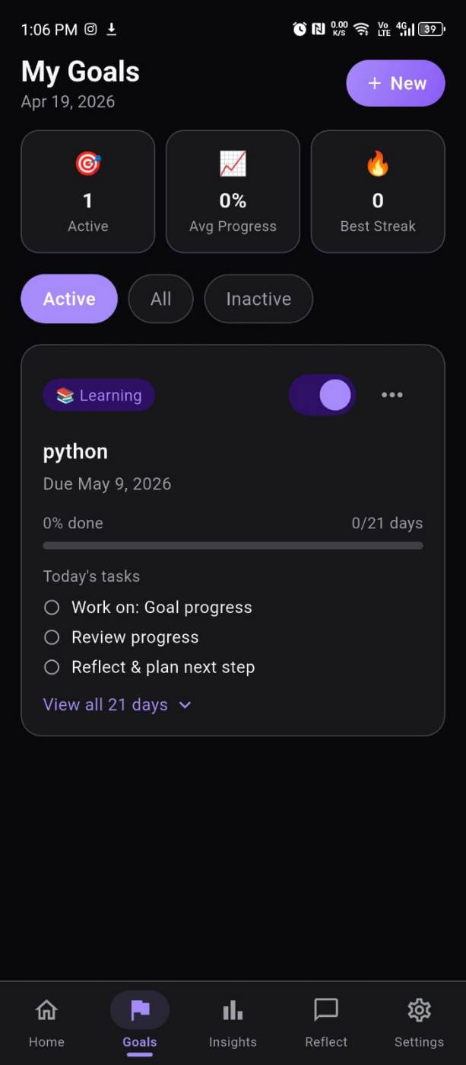
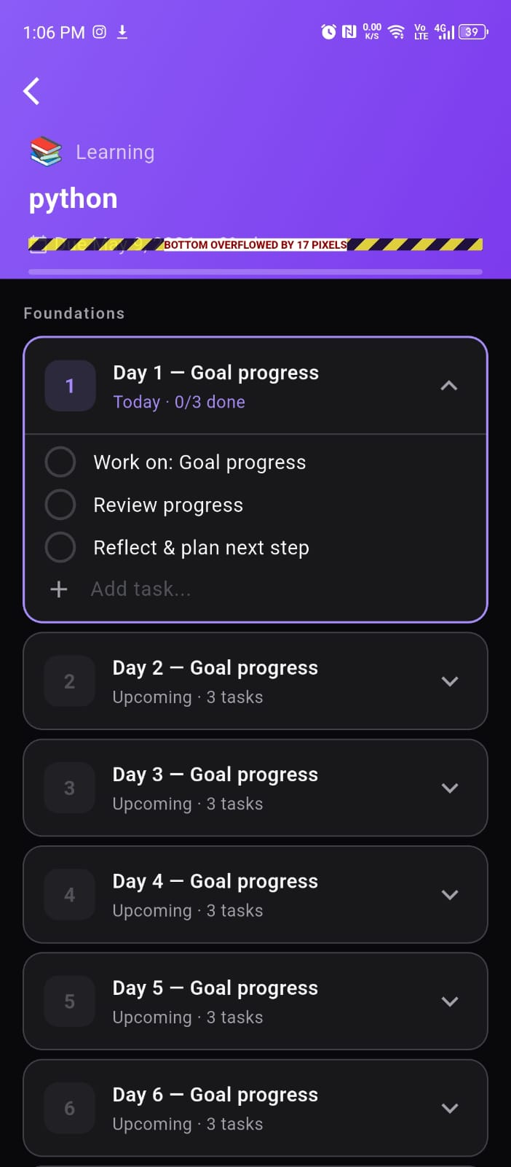
Sliding upward animation:
- Animation can’t be properly seen within screenshots
- Tap any goal card in the Goals tab
- Goal's title text physically flies from the card into the detail screen
- Header (white, 20px), morphing size and color mid-flight.
- Flutter handles the transition automatically using the matching tag.

Goal Screen
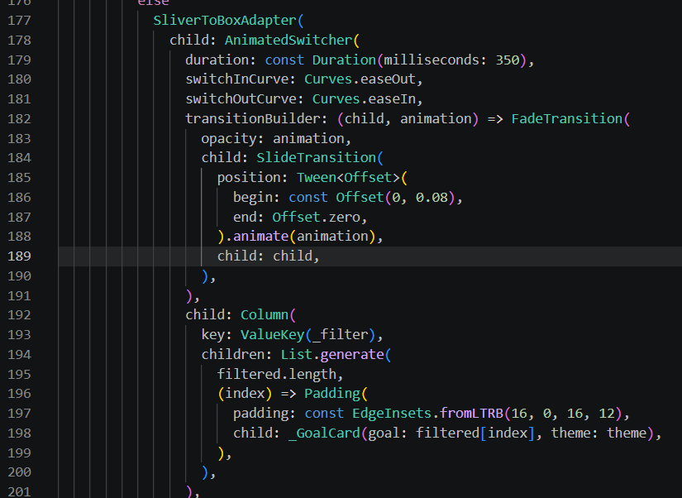

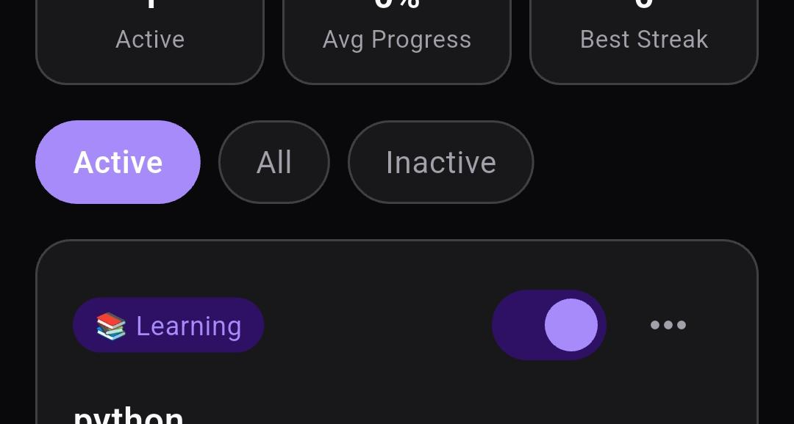
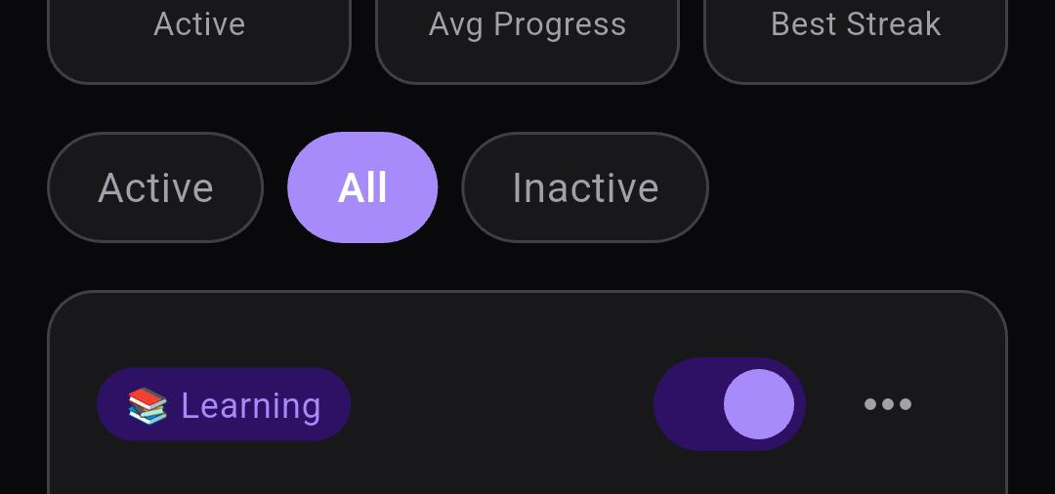
Goal Pill Animation:
- Animation can’t be properly seen within screenshots
- In Goals tab, the filter pills say Active / All / Inactive.
- Tapping a different filter causes the old list to fade out + slide away and the new list to fade in + slide up smooth 350ms crossfade with slide effect.

